Seng 299 A4

Oleg Matveenko

V00844836

Question 1.

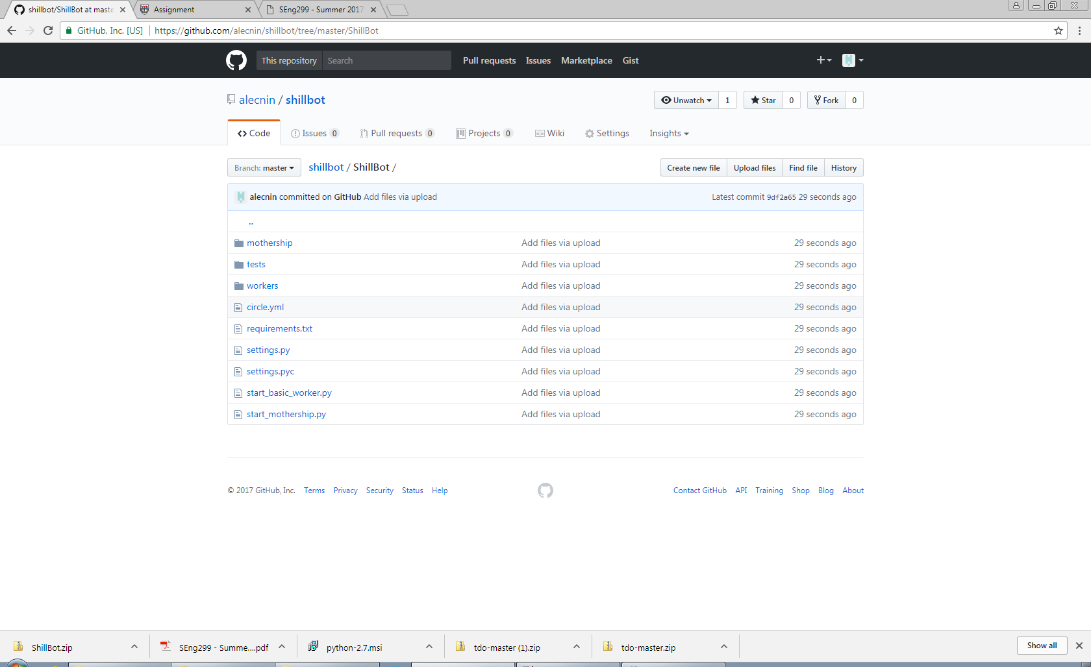

Question 2.

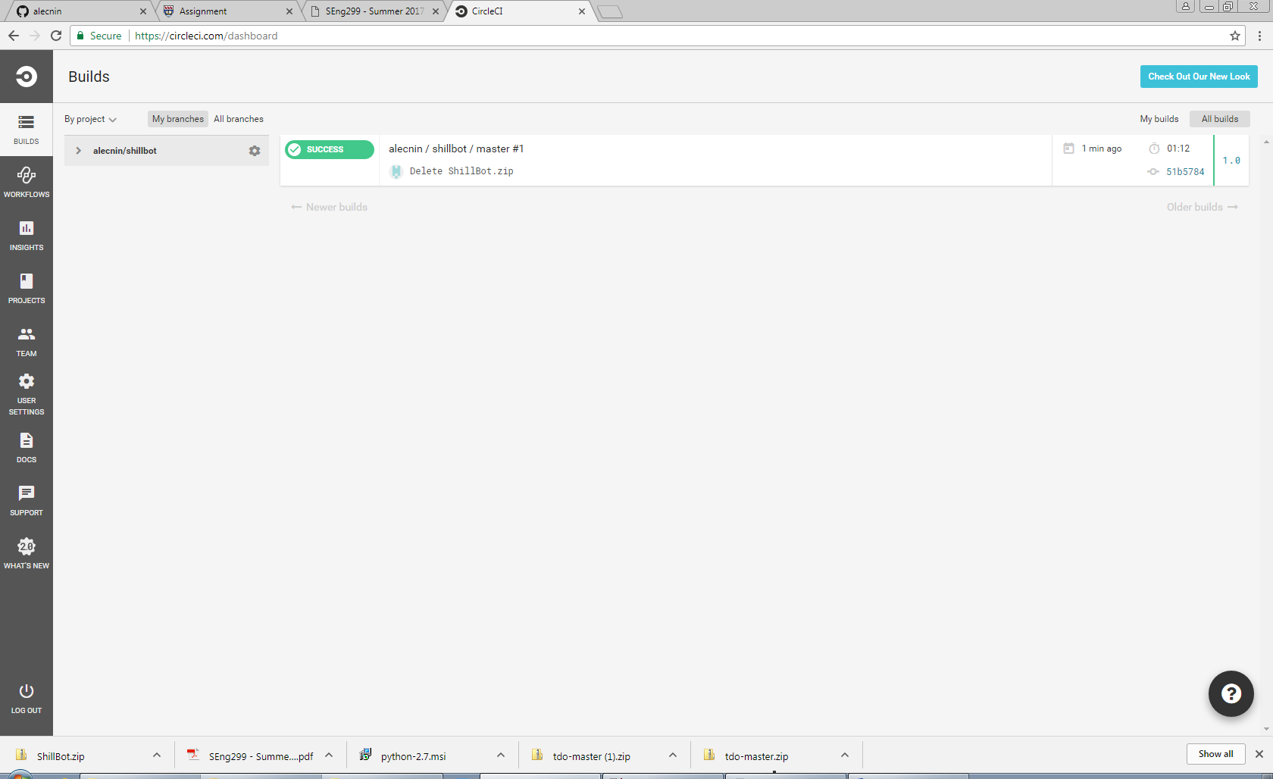

Question 3.